**COSC 4351**

**Name: _Jonathan Hirsch____**

**UML Modeling – WHAT Practice**

Apply the example from UML Modeling TUTORIAL to these requirements. Please complete as much as possible. Consider it the first iteration.

You must use Microsoft Word Case Tool.

1. (50 points)

**UML USE CASE Modeling**

**Perform “compilable” Textual Analysis with 4 steps for REQUIREMENTS Workflow.**

**You only need to show addDVD templated Use Case Description.**

**(NOTE: Choose the Use Case name following the naming convention for “C” modules and append UC before it))**

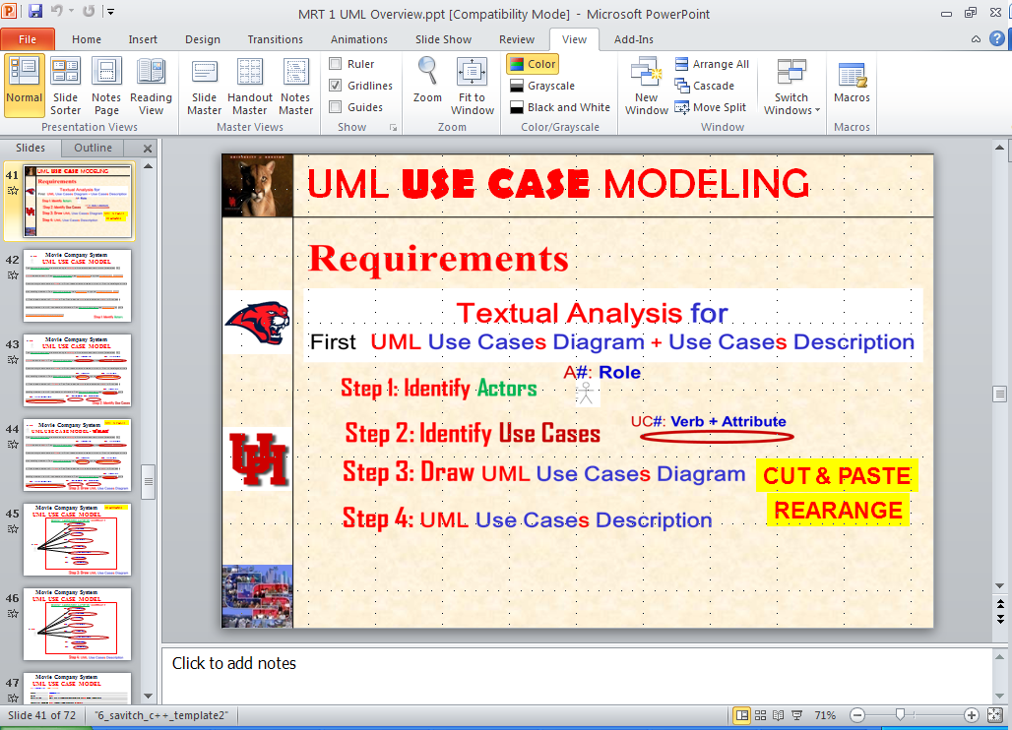

**(Please see the UML Models EXAMPLES on the last pages.**

**DVD Collection Application Requirements:**

**A1: User**

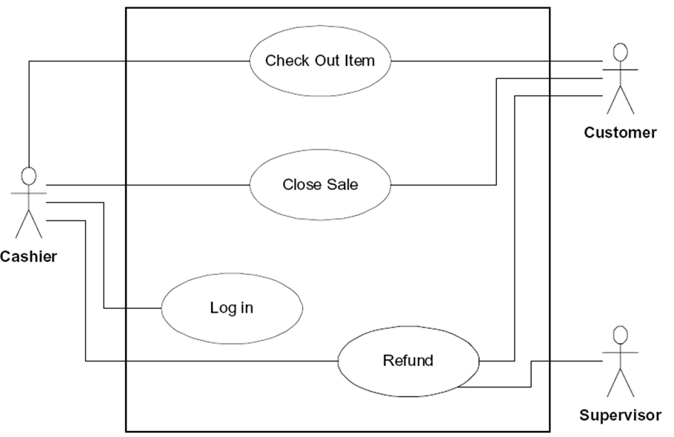

UC1: **UCAddArtist**

**Answer:**

UC5: **UCDisplayByYear**

UC4: **UCDisplayByCategory**

UC3: **UCEditDVD**

UC2: **UCRemoveDVD**

UC1: **UCAddDVD**

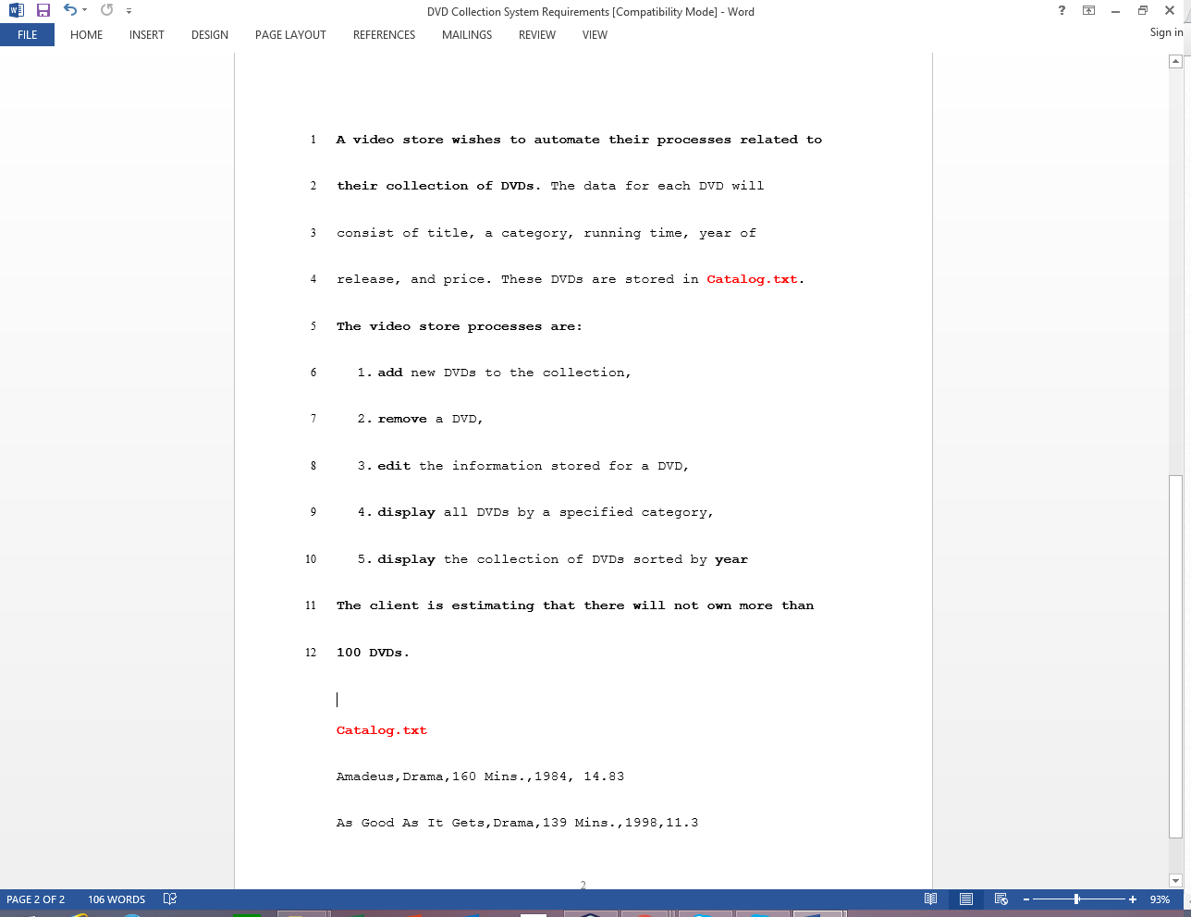

UC1: **UCAddDVD**

UC2: **UCRemoveDVD**

**A1: Employee**



UC4: **UCDisplayByCategory**

UC7: **UCRestoreCatalog**

UC6: **UCSaveCatalog**

UC5: **UCDisplayByYear**

UC3: **UCEditDVD**

**UC1 UCAddDVD Description**

|  |  |
| --- | --- |
| **Name:** | **UCAddDisc** |
| **Actor:** | **Employee** |
| **Description:** | **This use case describes the process used by User to Add another Disc for a particular artistName** |
| **Successful Completion:** | **Employee requests Adding DVD by DVD Title, Category, Time, Year, and Price**   1. **DVD Application checks to see if DVD does not already exist and there is room in DVDs array** 2. **If both are truth, DVD with DVD Title, Category, Time, Year, and Price is added at the end of the DVDs array and Successful message is sent to the Employee** |
| **Alternative:** | **Employee requests Adding DVD by DVD Title, Category, Time, Year, and Price**   1. **DVD Application checks to see if DVD does not already exist and there is room in DVDs array** 2. **If either is false, DVD is not added at the end of the DVDs array and Unsuccessful message is sent to the Employee** |
| **Pre-Condition:** | **Employee requests Add DVD** |
| **Post-Condition:** | **Disc DVD Added to the DVDs array successfully or Unsuccessfully** |
| **Assumptions:** | **None** |

**UML MVC CLASS Modeling MVC = model view control**

2. (50 points)

**Perform “compilable” Textual Analysis with 3 steps (1, 2, and 4) for ANALYSIS Workflows UML MVC CLASS DIAGRAM MODEL (you must use MVC design pattern).**

**(You do not need to show the methods).**

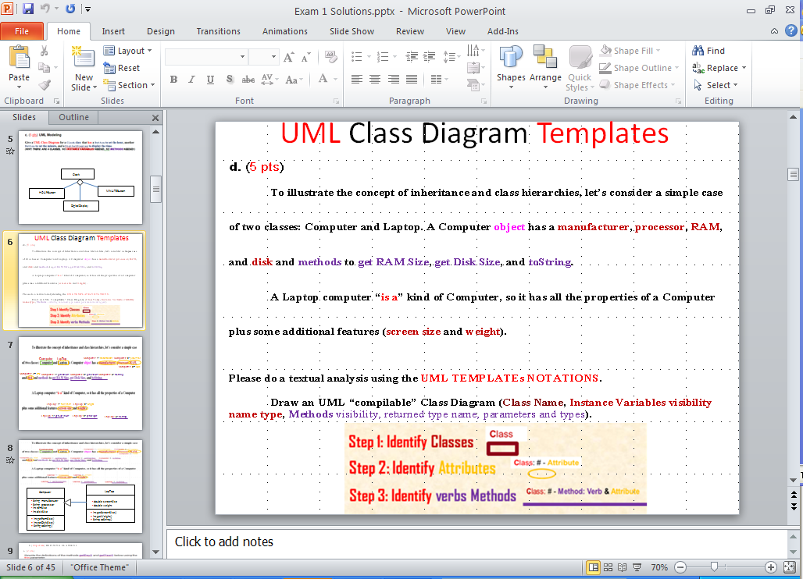

**Please see the UML Models EXAMPLES on the last pages.**

**Artist 1: name : String**

**Catalog**

**Controller 1: UCAddArtist(**String artist**);**

**Catalog 1: addArtist(**String artist**);**

|  |
| --- |
| **Controller** |
| - **catalog**: **Catalog** |
| + **UCAddArtist**(String artist): void // UC1  + **UCListArtists**(): void // UC2  + **UCAddDisc**(String artistName, String discCatalogNumber, String discTitle): void // UC3  + **UCListDiscs**(): void // UC4  + **UCAddTrack**(String discCatalogNumber, String trackTitle, double time): void // UC5  + **UClistTracksForDisc**(String discCatalogNumber): void // UC6  + **UCrestoreCatalog**(): void // UC7  + **UCsaveCatalog**(): void // UC8 |

**DVD Collection Application Requirements:**

**DVD: price**

**DVD: year**

**DVD: title**

**Collection: DVDs**

**DVD**

**DVD: time**

**DVD: category**

**Collection**



**Answer:**

|  |
| --- |
| **Collection** |
| - MAX_NUM_DVDS = 100  - DVDs:  **DVD[** MAX_NUM_DVDS **]**  - numOfDVDs : int |
| + **addDVD**(**DVD** DVD): void  + **removeDVD**(int index): void  + **editDVD** (**int** index, **DVD** DVD): void  + **displayByCat**(**string** category): void  + **displayByYear**(**int** year): void |

|  |
| --- |
| **DVD** |
| -title: **String**  -category: **int**  -year: **int**  -time: **float**  -price: **float**   |  |  | | --- | --- | |  | **Disc** | | -**MAX_TRACKS = 10 //1**  -discCatalogNumber: **String //2**  -numberOfTracks: **int //3**   * **tracks**: **Track[MAX_TRACKS] //4** * **artist**: **Artist //5** | |  | | + **addTrack**(**Track** track): void **//1**  + **getTrack(int i)**: **Track //2** | |
|
|  |

**Example UML USE CASE Model:**

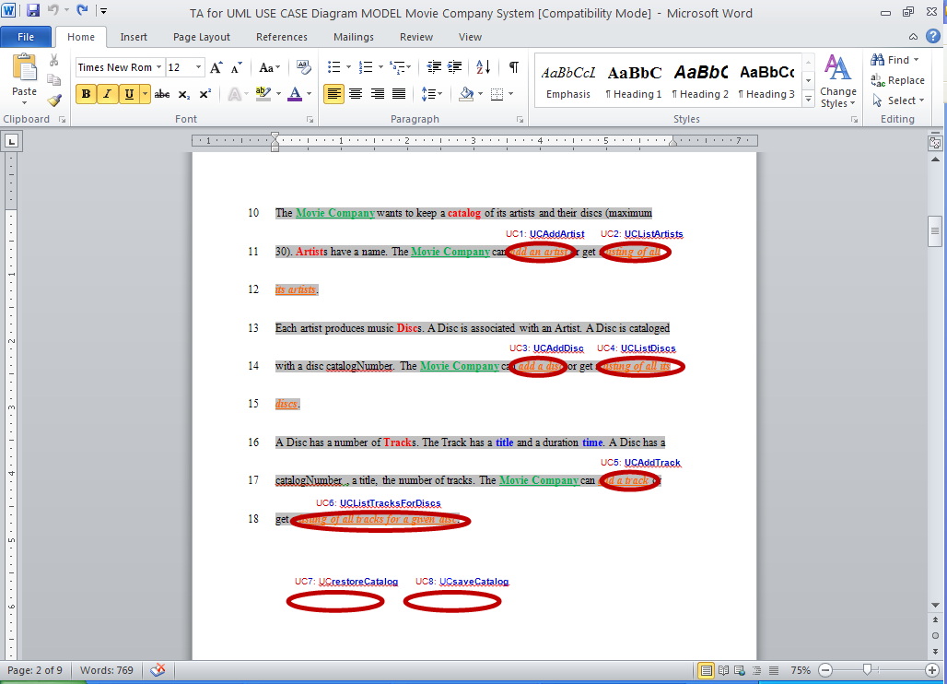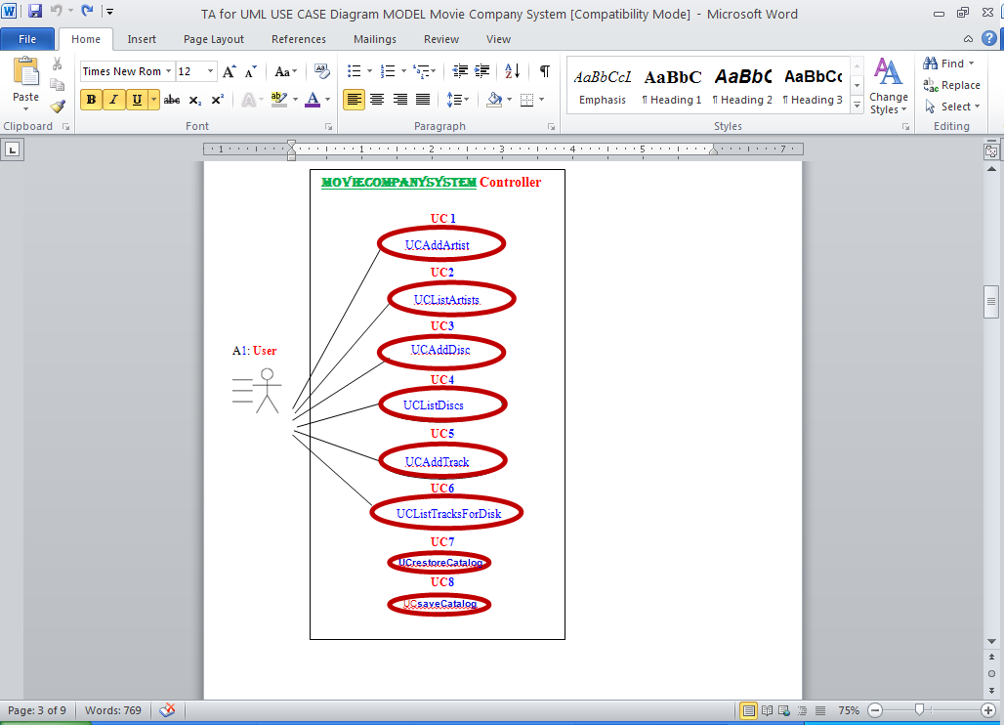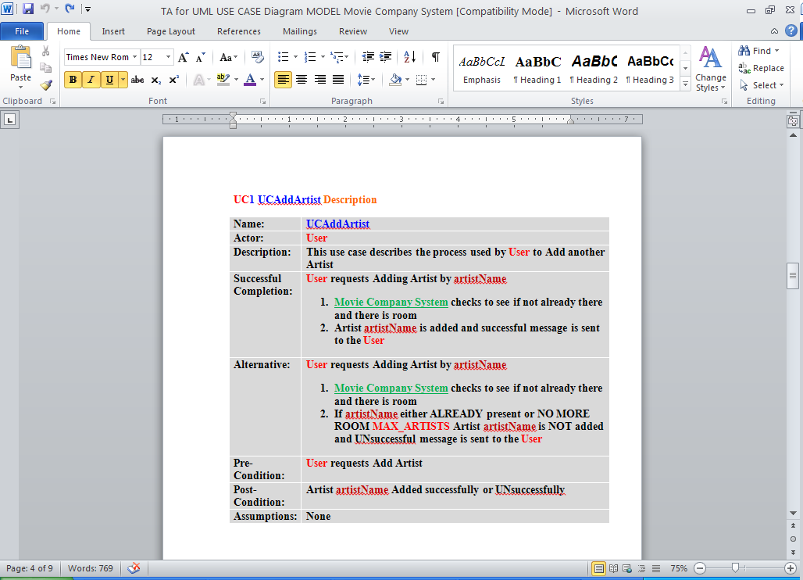

**Example UML MVC CLASS Model:**

